

Midterms & Markets
Key Takeaways
- Historically, midterm elections have cost the incumbent presidential party seats in the House of Representatives.
- During midterm election years, market returns tend to be range-bound and volatility remains elevated compared to non-election years.
- Over the long-term, however, markets don’t see red or blue but simply green and have gone up regardless of the party in power.
Midterm elections are around the corner, and the outcome will determine which party has control of the House of Representatives and the Senate. The result can also be a signal for the next presidential election. Midterm elections are important as they can have significant potential impact on policy and laws. In this edition, we look at how the balance of power has historically shifted during midterms and what, if any, impact it has had on the stock market.
How Midterms Impact the Control in Congress
Midterm elections have historically been challenging for the incumbent president’s party. The impact has been clear in the House of Representatives, while the Senate has shown mixed results. Since 1946, the president’s party has lost an average of 25 seats in the House of Representatives in 17 of the 19 midterm elections. The consistency in losses can be attributed to a myriad of reasons, including higher motivation for voters of the opposing party who view the midterms as a referendum on the administration and general dissatisfaction with the state of the economy. The exceptions in 1998 and 2002 were tied to unique circumstances. In 1998 a strong economy helped, while in 2002, voters rallied around the incumbent president post the 9/11 attacks. In 2022, record-high inflation and concerns about the state of the economy will likely play critical roles in the upcoming elections.
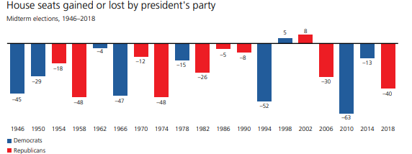
Source: UBS
Stock Market & Midterm Election
During midterm election years, market returns tend to be range-bound, and volatility remains elevated compared to non-election years. While markets are impacted by a variety of forces, such as inflation, the direction of interest rates or the state of the job market, the subdued returns prior to elections and generally higher volatility are likely explained by the fact that markets don’t like the uncertainty from potential policy changes.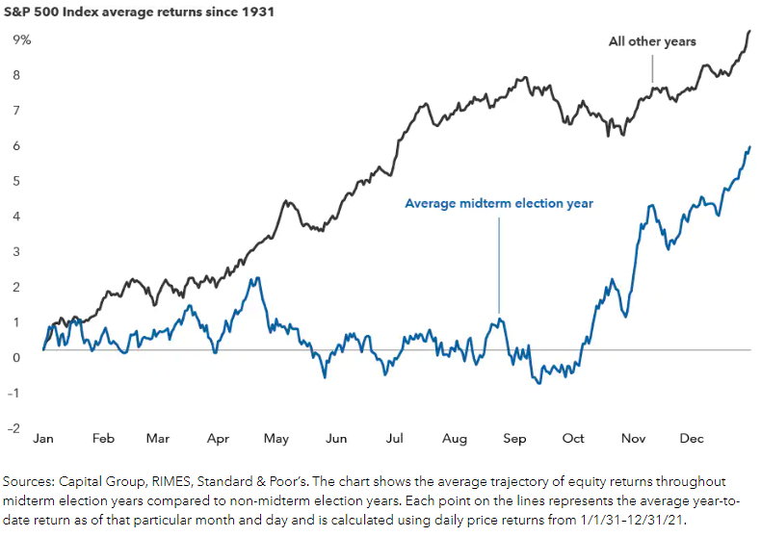
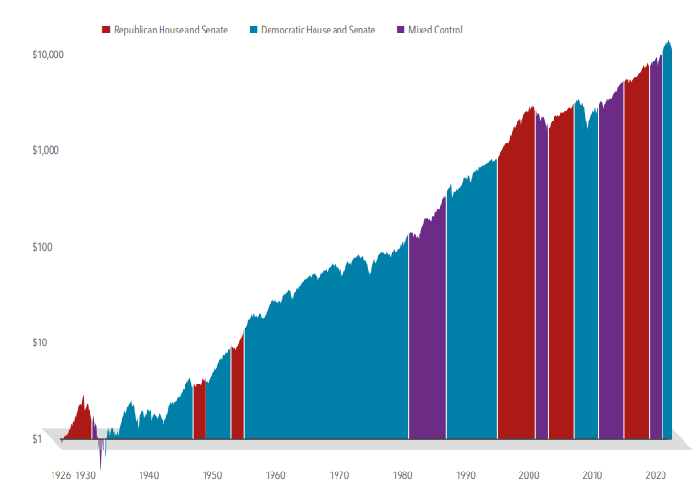
HYPOTHETICAL GROWTH OF $1 INVESTED IN S&P 500 INDEX. Source: Dimensional Funds. Data from 1/1/26-6/30/22

Regardless of the outcome of the elections, market returns for the one year following midterms and over the long term have historically been strong. Since 1930, the average return for the 12-month period after a midterm election is 13% compared with 5.5% for other years. Only in two
instances did the market have negative returns for the 12-month period after midterm election years: in 1930-31 and 1938-39. Each of these periods were aligned with the economic challenges of the Great Depression and the early onset of WWII.
Finally, data over the last nearly 100 years shows that investors who remained disciplined and invested in the S&P 500 from January 1, 1926, through June 30, 2022, would have seen growth in their equity portfolio

regardless of whether Democrats or Republicans controlled the House and Senate or whether control was mixed as seen in the final chart.
Many may think that’s all in the past, and this time is different. Indeed, there are many important issues facing our country today; however, markets don’t see red or blue, only green. The factors that will dictate the markets include interest rates set by the Federal Reserve, continued innovation, and ongoing consumer spending, not simply elections. Nearly a century’s worth of data has shown using elections alone to make investment decisions is likely to lead to unreliable investment results.

AssetMark, Inc.
1655 Grant Street
10th Floor
Concord, CA 94520-2445
800-664-5345
IMPORTANT INFORMATION
This is for informational purposes only, is not a solicitation, and should not be considered investment, legal or tax advice. The information in this report has been drawn from sources believed to be reliable, but its accuracy is not guaranteed, and is subject to change. Investors seeking more information should contact their financial advisor. Financial advisors may seek more information by contacting AssetMark at 800-664-5345.
Investing involves risk, including the possible loss of principal. Past performance does not guarantee future results. Asset allocation cannot eliminate the risk of fluctuating prices and uncertain returns. There is no guarantee that a diversified portfolio will outperform a non-diversified portfolio. No investment strategy, such as asset allocation, can guarantee a profit or protect against loss. Actual client results will vary based on investment selection, timing, market conditions, and tax situation. It is not possible to invest directly in an index. Indexes are unmanaged, do not incur management fees, costs and expenses and cannot be invested in directly. Index performance assumes the reinvestment of dividends.
Investments in equities, bonds, options, and other securities, whether held individually or through mutual funds and exchange traded funds, can decline significantly in response to adverse market conditions, company-specific events, changes in exchange rates, and domestic, international, economic, and political developments.
You agree not to redistribute the Information to recipients not authorized by AssetMark. You agree that the Providers are considered to be third-party beneficiaries of the Terms of Use.
AssetMark, Inc. is an investment adviser registered with the U.S. Securities and Exchange Commission. AssetMark and third-party service providers are separate and unaffiliated companies. Each party is responsible for their own content and services.
©2022 AssetMark, Inc. All rights reserved.
104708 | C22-19167 | 09/2022 | EXP 09/30/2024

IMPORTANT INFORMATION
This is for informational purposes only, is not a solicitation, and should not be considered investment, legal or tax advice. The information in this report has been drawn from sources believed to be reliable, but its accuracy is not guaranteed, and is subject to change. Investors seeking more information should contact their financial advisor. Financial advisors may seek more information by contacting AssetMark at 800-664-5345.
Investing involves risk, including the possible loss of principal. Past performance does not guarantee future results. Asset allocation cannot eliminate the risk of fluctuating prices and uncertain returns. There is no guarantee that a diversified portfolio will outperform a non-diversified portfolio. No investment strategy, such as asset allocation, can guarantee a profit or protect against loss. Actual client results will vary based on investment selection, timing, market conditions, and tax situation. It is not possible to invest directly in an index. Indexes are unmanaged, do not incur management fees, costs and expenses and cannot be invested in directly. Index performance assumes the reinvestment of dividends.
Investments in equities, bonds, options, and other securities, whether held individually or through mutual funds and exchange traded funds, can decline significantly in response to adverse market conditions, company-specific events, changes in exchange rates, and domestic, international, economic, and political developments.
AssetMark, Inc. is an investment adviser registered with the U.S. Securities and Exchange Commission. AssetMark and third-party service providers are separate and unaffiliated companies. Each party is responsible for their own content and services.
©2022 AssetMark, Inc. All rights reserved.
103305 | C22-18578 | 05/2022 | EXP 05/31/2024

AssetMark, Inc.
1655 Grant Street
10th Floor
Concord, CA 94520-2445
800-664-5345

UBS. 2022 Election Watch.
Capital Group: Can midterm elections move markets? 5 charts to watch
UBS. 2022 Election Watch.
Dimensional Funds. What History Tells Us C22-about the Market and Control of US Congress Securities and Advisory services offered through LPL Financial, a Registered Investment Advisor. Member FINRA/SIPC.

